LAB

REPORT

CSE 114 : Data Structure and Algorithms Sessional

|  |  |
| --- | --- |
| PREPARED BY  Mehrin Farzana  ID: 2101013  Session: 2021-2022  Date: 31/10/2023 | SUPERVISED BY  Suman Saha  Lecturer  Department of IRE, BDU |

|  |  |
| --- | --- |
| logo1 | BANGABANDHU SHEIKH MUJIBUR RAHMAN DIGITAL UNIVERSITY  (BDU) |
|  |  |

**List of Problems**

1. Floyd warshall algorithm.
2. Dijsktra algorithm.

**Problem No.:** 01

**Problem Statement:**

Floyd warshall algorithm.

**Code:**

#include<stdio.h>

int main(){

int n;

printf("Enter number of vatices: ");

scanf("%d", &n);

int a[n][n];

printf("Enter graph as adjecency matrix(100 for Infinity): \n");

for(int i=0; i<n; i++){

for(int j=0; j<n; j++){

scanf("%d", &a[i][j]);

}

}

for(int k=0; k<n; k++){

for(int i=0; i<n; i++){

for(int j=0; j<n; j++){

if(a[i][j]>(a[i][k]+a[k][j])){

a[i][j]=a[i][k]+a[k][j];

}

}

}

}

for(int i=0; i<n; i++){

for(int j=0; j<n; j++){

printf("%d\t", a[i][j]);

}

printf("\n");

}

return 0;

}

**Output:**

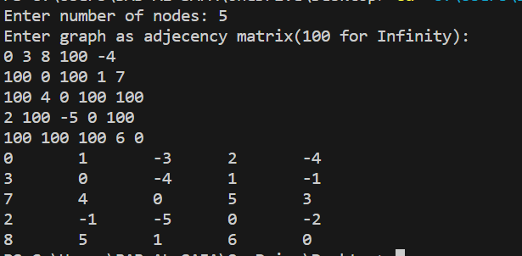

Fig 1.1: Output on console for case 1.

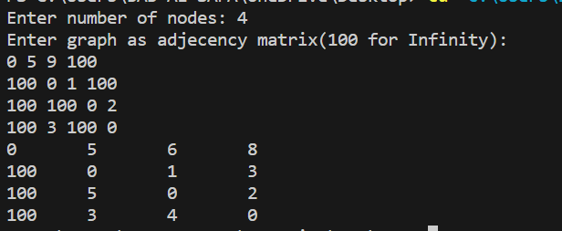

Fig 1.1: Output on console for case 1.

**Problem No.:** 02

**Problem Statement:**

Dijsktra algorithm.

**Code:**

#include <stdio.h>

#define INFINITY 9999

#define MAX 10

void Dijkstra(int Graph[MAX][MAX], int n, int start);

void Dijkstra(int Graph[MAX][MAX], int n, int start) {

int cost[MAX][MAX], distance[MAX], pred[MAX];

int visited[MAX], count, mindistance, nextnode, i, j;

// Creating cost matrix

for (i = 0; i < n; i++)

for (j = 0; j < n; j++)

if (Graph[i][j] == 0)

cost[i][j] = INFINITY;

else

cost[i][j] = Graph[i][j];

for (i = 0; i < n; i++) {

distance[i] = cost[start][i];

pred[i] = start;

visited[i] = 0;

}

distance[start] = 0;

visited[start] = 1;

count = 1;

while (count < n - 1) {

mindistance = INFINITY;

for (i = 0; i < n; i++)

if (distance[i] < mindistance && !visited[i]) {

mindistance = distance[i];

nextnode = i;

}

visited[nextnode] = 1;

for (i = 0; i < n; i++)

if (!visited[i])

if (mindistance + cost[nextnode][i] < distance[i]) {

distance[i] = mindistance + cost[nextnode][i];

pred[i] = nextnode;

}

count++;

}

// Printing the distance

for (i = 0; i < n; i++)

if (i != start) {

printf("\nDistance from source to %d: %d", i+1, distance[i]);

}

}

int main() {

int Graph[MAX][MAX], i, j, n, u;

scanf("%d", &n);

for(int i=0; i<n; i++){

for(int j=0; j<n; j++){

scanf("%d", &Graph[i][j]);

}

}

u = 0;

Dijkstra(Graph, n, u);

return 0;

}

**Output:**

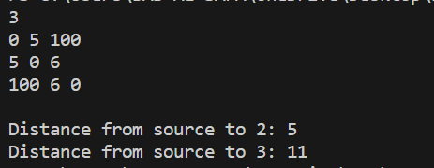

Fig 1.1: Output on console for case 1.

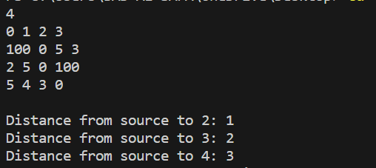

Fig 1.2: Output on console for case 2.

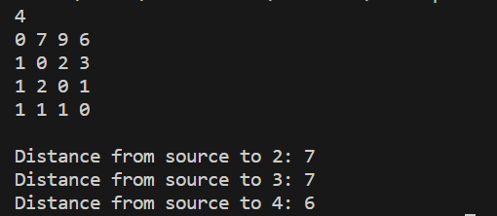

Fig 1.3: Output on console for case 3.